CSIR initiative on recycling of COVID-19 plastic waste into value-added products: Value creation from recycling biomedical waste
Large quantities of PPE kits (nonwoven polypropylene) are used for battling the COVID-19 pandemic. As per CPCB mandates, used PPE kits have to be incinerated or land-filled. This is an abject loss of monetory and energy values besides burdening the environment. Hence, CSIR-National Chemical Laboratory (CSIR-NCL) embarked on a project to develop an alternative process to manage the PPE waste gainfully.With funding from CSIR and early support from CSIR-IIP, initial lab-scale experiments at CSIR-NCL showed that the PPE plastic waste could be successfully converted into molded articles with quality comparable to those made from virgin polymers. To scale up the further development, Reliance Industries Ltd. (RIL) was onboarded as knowledge partner who then networked with other executing partners.The pilot scale development being presented here interfaced with regulatory, technical, logistics, manufacturing, testing and prototyping of useful plastic articles made from a polymer resource that would have otherwise been wastefully disposed. It involved the use of fundamental understanding of polymer science, plastics technology and a network of supply chain. Although this project aimed at developing non-food contact articles of common use, we also produced high-performance automotive components. Attention was paid to build seeding points for further scaling-up and diversification of this recycling technology. These collaborative efforts have led to a recycling technology that can contribute to India’s commitment of Panchamrit announced by Hon. PM at COP26, if widely adopted. To facilitate this it has been decided to freely release this technology in the public domain to Indians with appropriate safeguards.
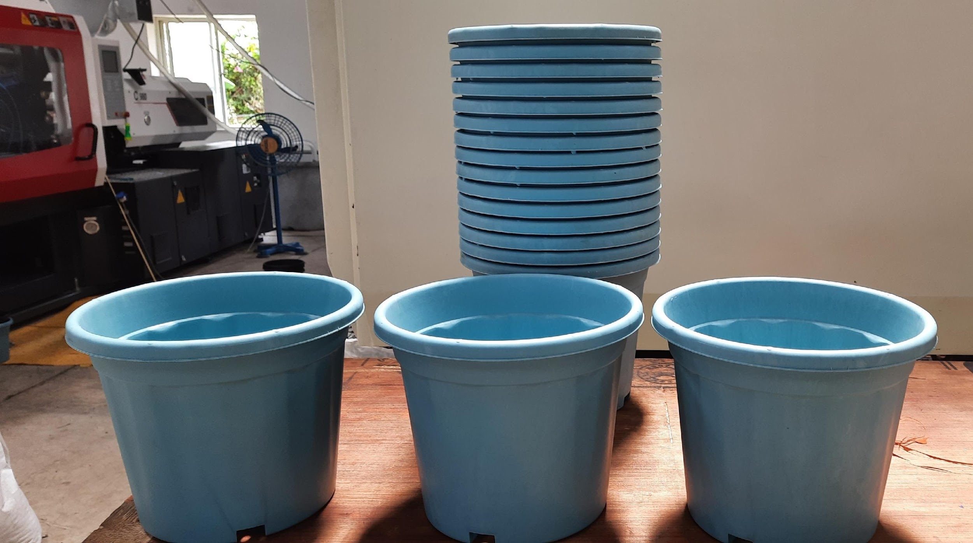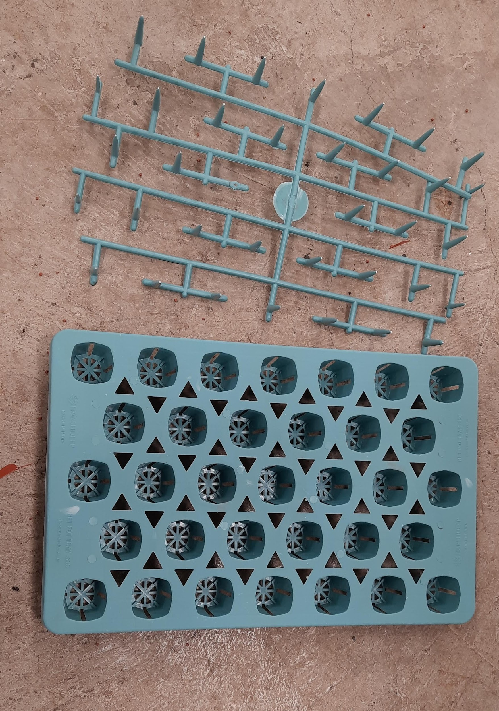

Figure 1 Garden pots & plant grower trays made from decontaminated recycled PPE material

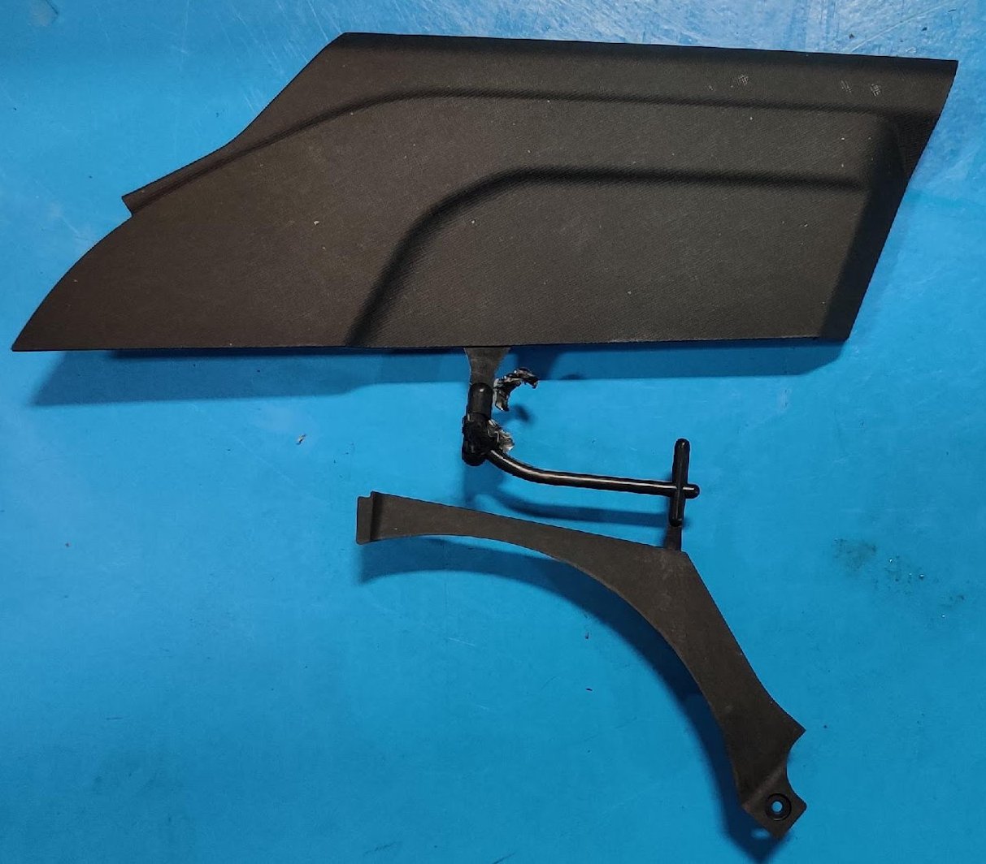
Figure 2 Long glass fiber themoplastic composite molded structural automotive part made from decontaminated recycled PPE material

